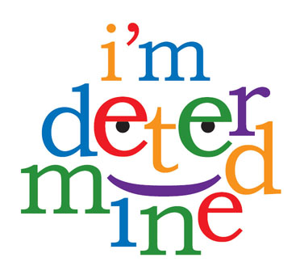

Mandy

Support

What needs to happen to make it a Good Day?

* I need to wake on my own. I am a heavy sleeper. Waking me up I am like a bear, grrrrrrr!!!!!

I must be respectful to my mom and brother. No screaming or using bad words. I must help to dress myself.

I am cranky without food. Mom makes sure I eat breakfast

I will settle down as soon as I get my meds. Taking them late will not help me stay focused

* yes, most mornings

Yes, if I am nice to my mom

Yes, during the week I eat at school. On the weekends my mom makes sure I get a good breakfast

Yes, My mom makes sure I do, because I just can't control my actions without them

* I wake up on my own "feeling good"
* I like iPad time in the morning
* I eat breakfast
* I get my morning meds
* I help to dress myself

What happens on a Good Day?

Who can help me?

Now





* Mom and me. I need to get to bed by 8:30pm, even on the weekends

It is up to me, but mom helps to keep my routine the same because I need it

My mom and the ladies in the cafeteria at school.

That is a job for my Mom

GoodDay

Does it happen now?

**My Good Day Plan**